**PRIVATE REPO CONTENT HOSTING ON HTTPD USING JENKINS JOB**

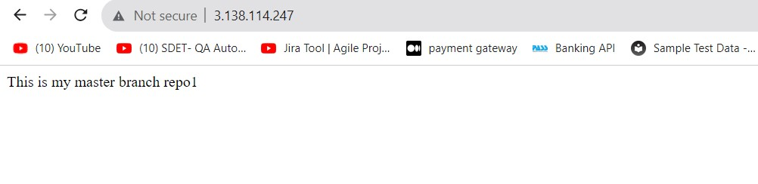

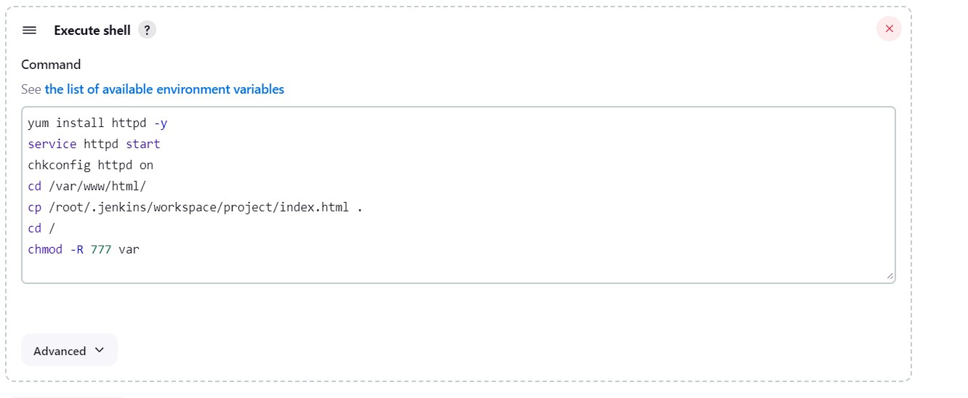

STEPS: -

* Launch & connect to instance.
* Install java install java-11-amazon-corretto.x86_64.
* Download tomcat 9.zip file, unzip it. And give Apache tomcat directory 777 permissions.

(chmod -R 777 dirname)

* Go to webapps directory present in Apache tomcat directory.
* Download Jenkins.war file in webapps directory.
* Go to bin >> ./startup.sh (start the server)
* Check publicip:8080/Jenkins (to open Jenkins)
* Configure Jenkins.

**Job 1: -**

* Go to instance & install git.
* Go to Jenkins >> manage Jenkins >> credentials >> click on global >> add credentials.
* Select kind as username & password.
* Enter GitHub username.
* Paste GitHub token in password.
* Write git-token in ID and description box.
* Save.
* Create job
* Enter name >> select freestyle project >> click ok
* Add description
* Select git in SCM.
* Enter repository URL.
* Select credentials
* Enter branch master
* Build setup >> select execute shell
* Enter commands

yum install httpd -y

service httpd start

chkconfig httpd on

cd /var/www/html

cp /root/.jenkins/workspace/project/index.html .

cd /

chmod -R 777 var

* Build the job
* Check public Ip on google
* The index.html file present on GitHub private repository will be hosted.

**Job 2:-**

* Go to instance & install git.
* Go to Jenkins >> manage Jenkins >> credentials >> click on global >> add credentials.
* Select kind as username & password.
* Enter GitHub username.
* Paste GitHub token in password.
* Write git-token in ID and description box.
* Save.
* Create job
* Enter name >> select freestyle project >> click ok
* Add description
* Select git in SCM.
* Enter repository URL.
* Select credentials
* Enter branch dev
* Build setup >> select execute shell
* Enter commands

yum install httpd -y

service httpd start

chkconfig httpd on

cd /var/www/html

cp /root/.jenkins/workspace/project/index.html .

cd /

chmod -R 777 var

* Build the job
* Check public Ip on google
* The index.html file present on GitHub private repository will be hosted.

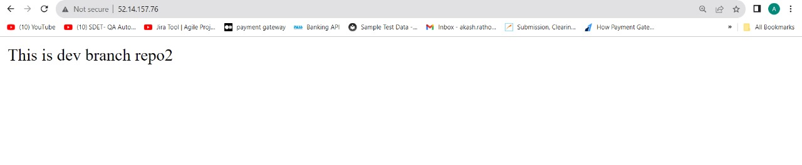

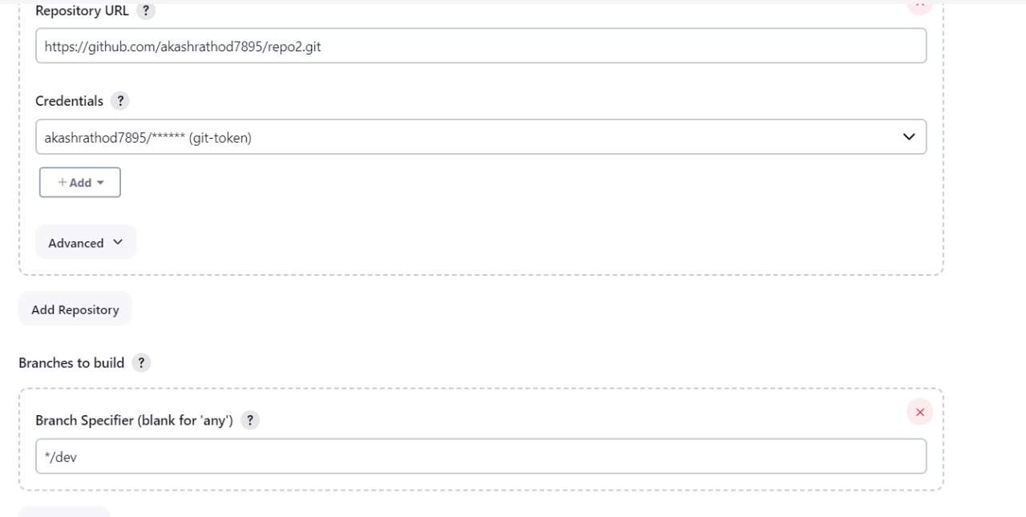

* **If we run the job 1 and search instance_Ip, we will get the page which has the private repo1 content from master branch.**
* **If we run the job 2 and search instance_Ip, we will get the page which has the private repo2 content from dev branch.**